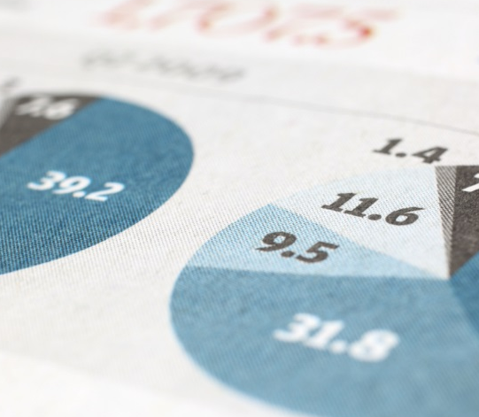
Module End Assignment-MYSQL
E-Commerce Customer Churn Analysis
Aswathi Ravi | 14-09-2026 | DA60

Introduction
This project focuses on E-Commerce Customer Churn Analysis using MySQL. It aims to analyze customer data to understand the factors associated with customer churn, including tenure, payment mode, satisfaction, complaints, and purchasing behaviour. The data is cleaned, transformed, and analyzed using SQL to identify patterns between active and churned customers. The findings can help e-commerce businesses improve customer retention and support better decision-making.
Objective
- To analyze customer churn in an e-commerce business using MySQL.
- To clean and transform the customer data.
- To identify factors related to customer churn.
- To compare the behaviour of active and churned customers.
- To generate useful insights that can help improve customer retention.
Data Cleaning:
Handling Missing Values and Outliers:
- Impute mean for the following columns, and round off to the nearest integer if required: WarehouseToHome, HourSpendOnApp, OrderAmountHikeFromlastYear, DaySinceLastOrder.
Ans: Found out the number of null values in each column
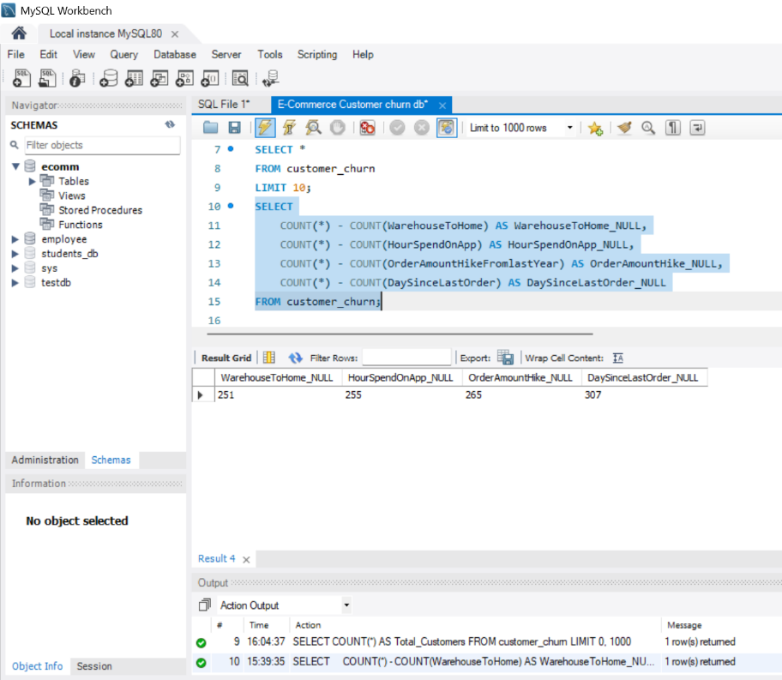

Calculated the mean
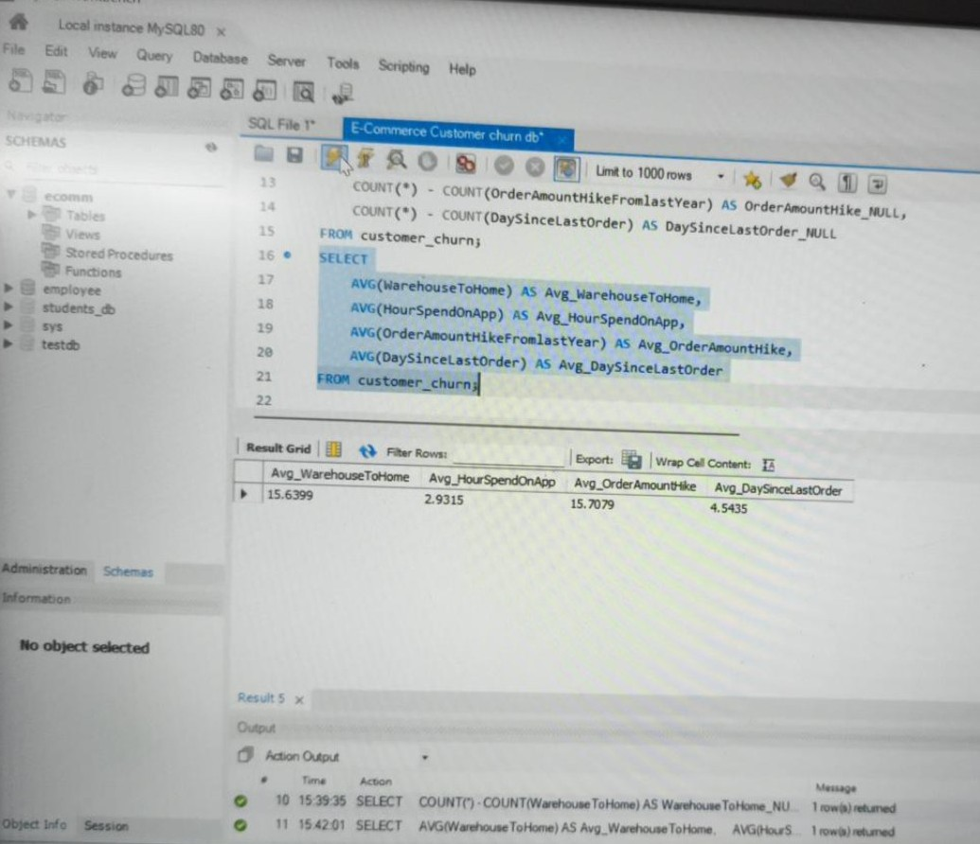

Updated the null values as rounded values as instructed
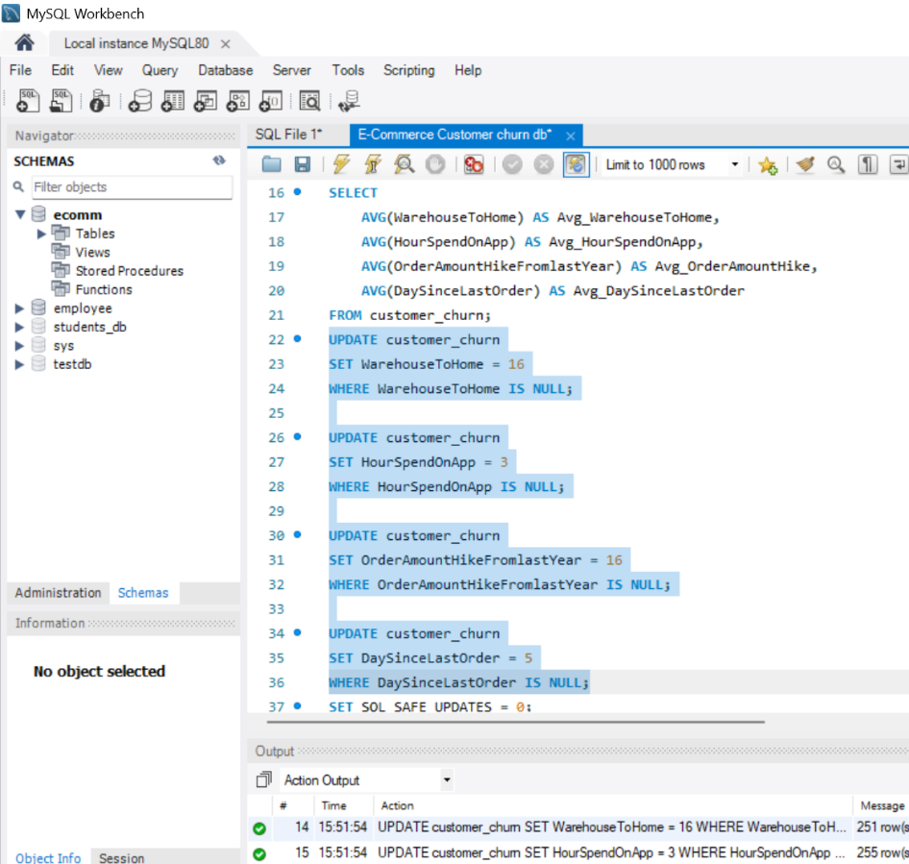

Verified the updated columns
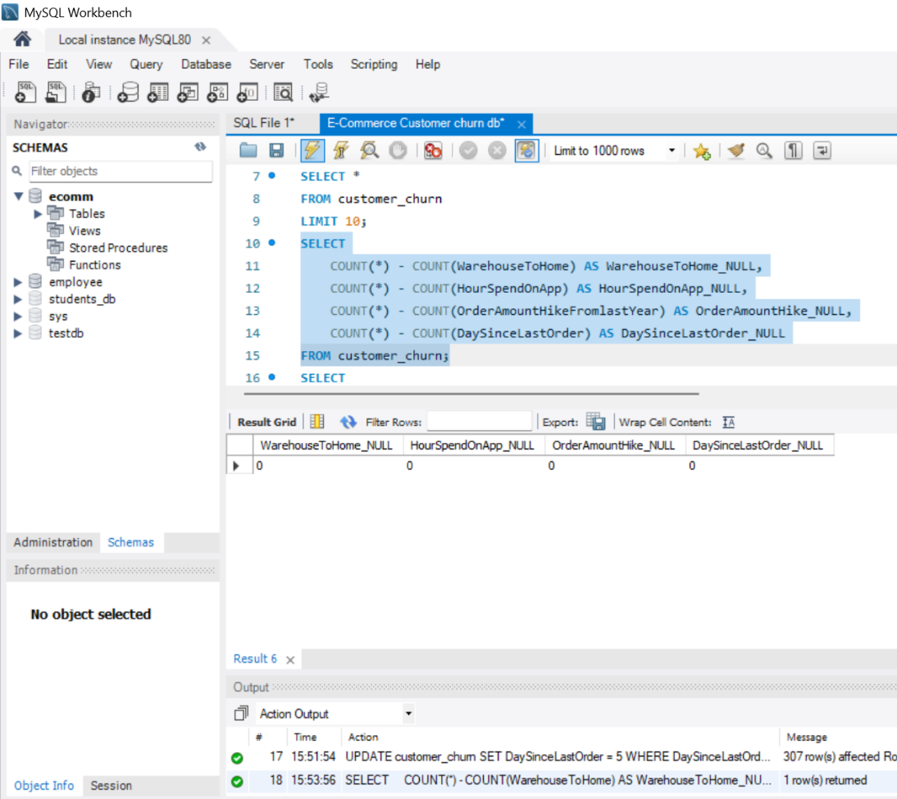

- Impute mode for the following columns: Tenure, CouponUsed, OrderCount.
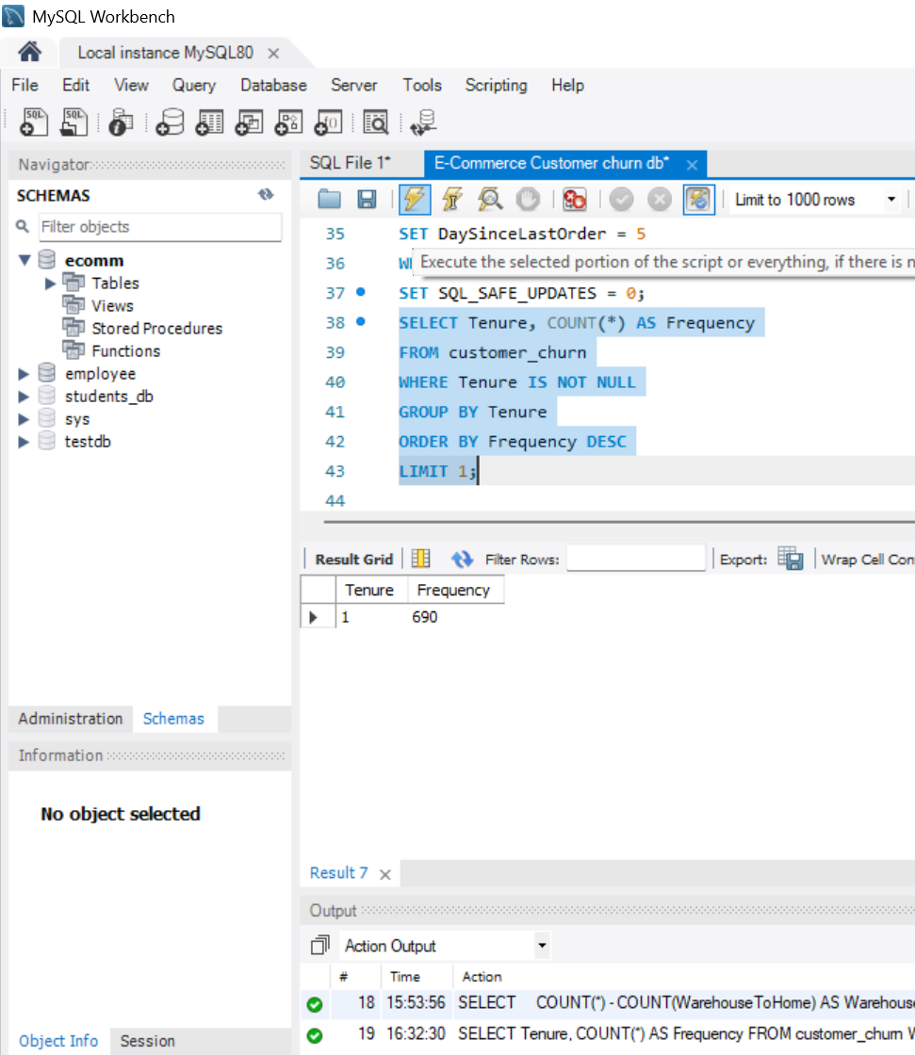

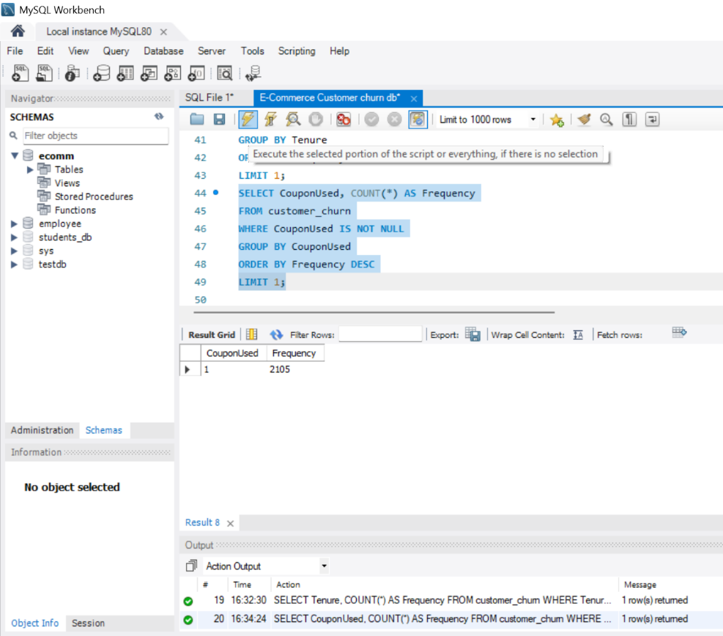

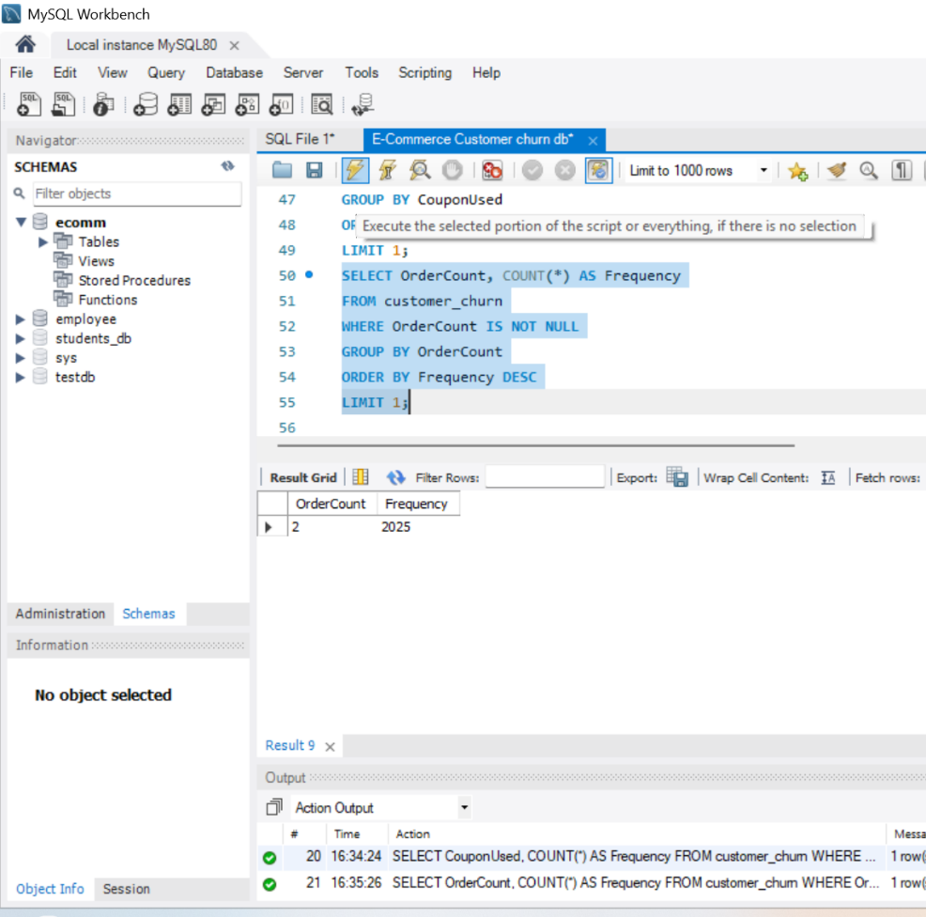

Updated the mode and verified it
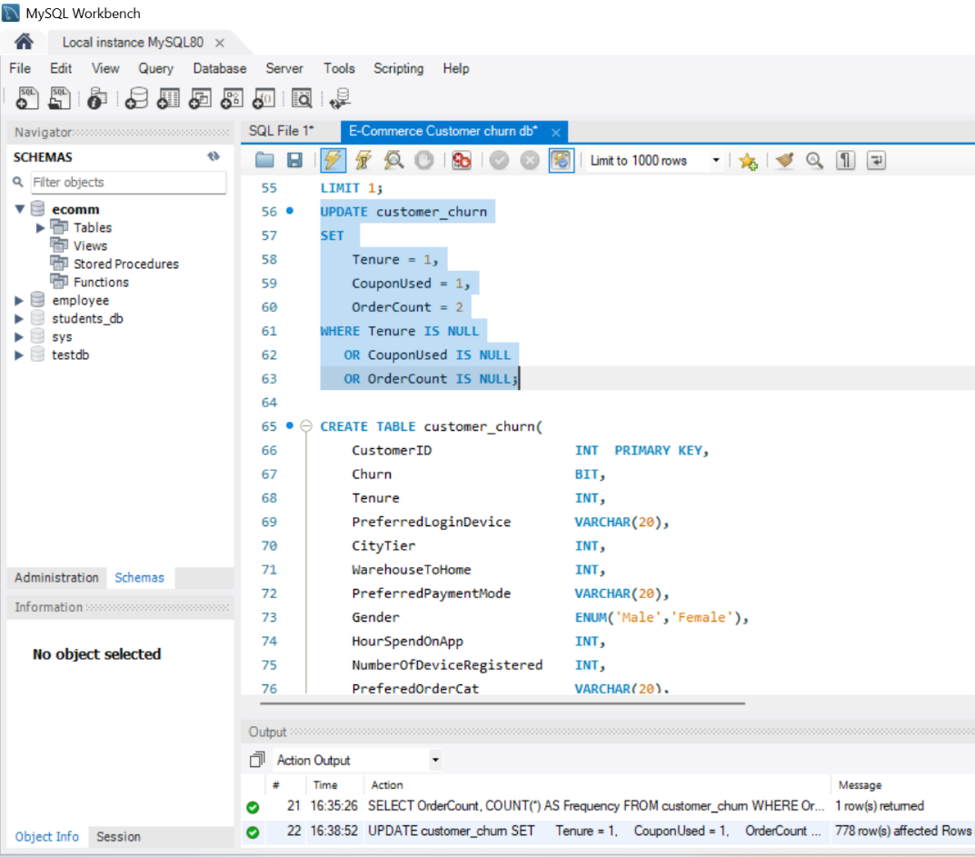

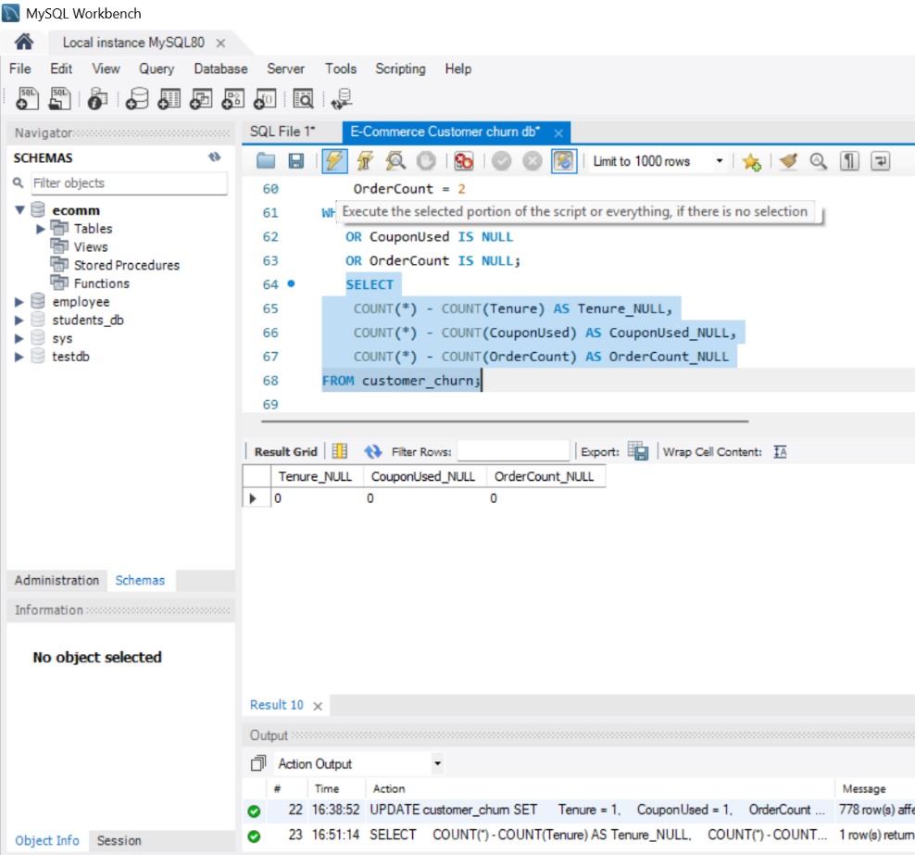

- Handle outliers in the 'WarehouseToHome' column by deleting rows where the values are greater than 100.
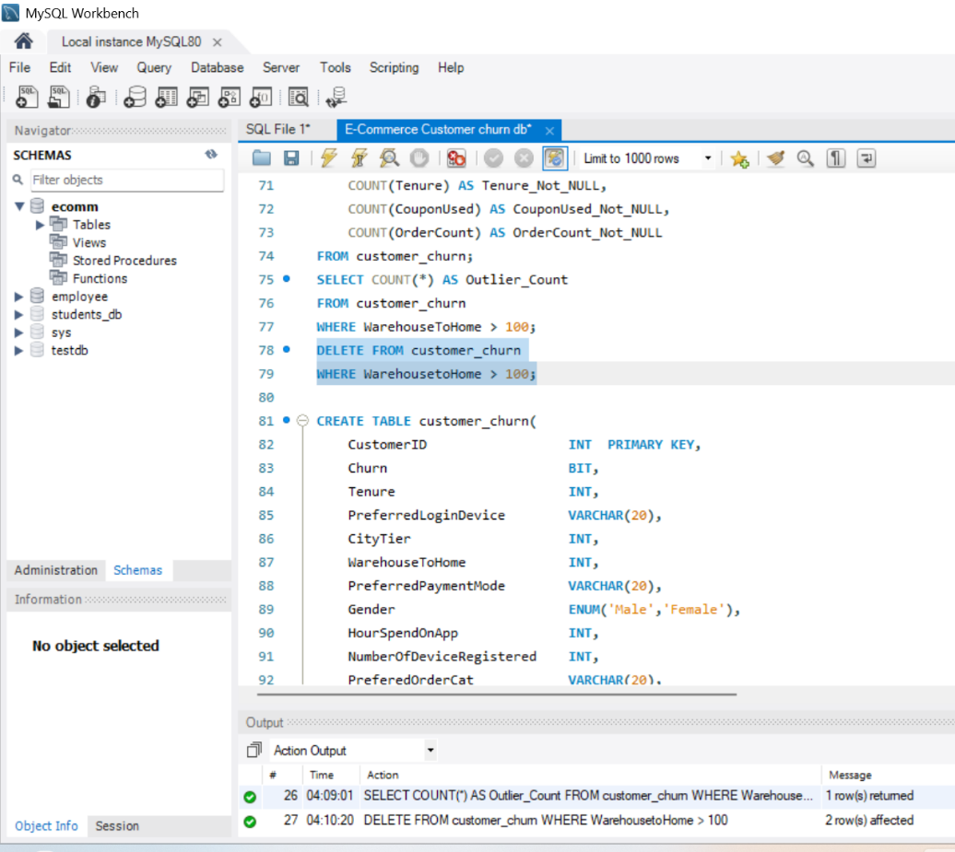

Dealing with Inconsistencies:
- Replace occurrences of “Phone” in the 'PreferredLoginDevice' column and “Mobile” in the 'PreferedOrderCat' column with “Mobile Phone” to ensure uniformity.
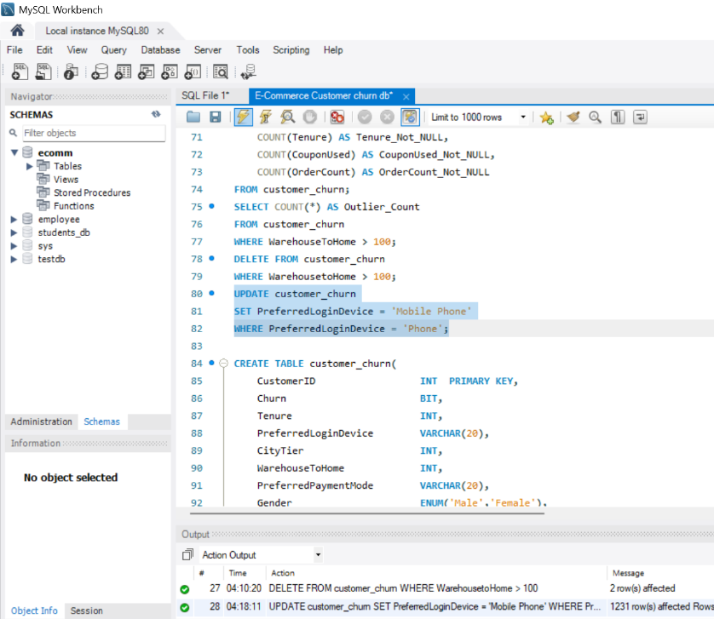

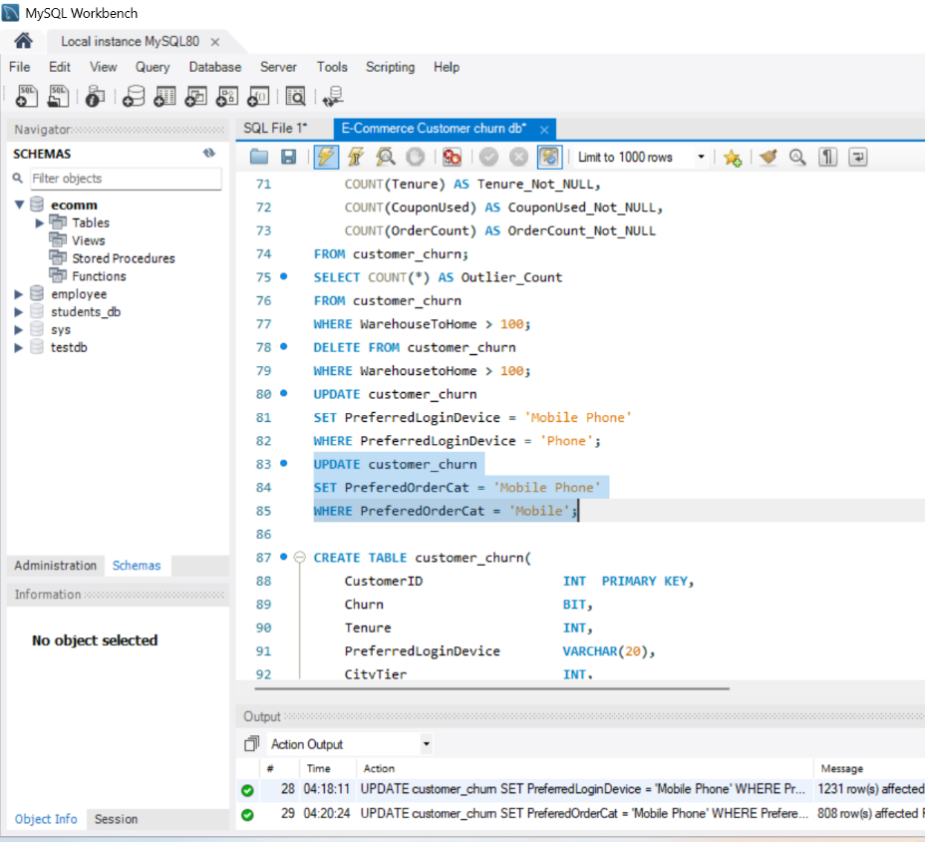

- Standardize payment mode values: Replace "COD" with "Cash on Delivery" and "CC" with "Credit Card" in the PreferredPaymentMode column.
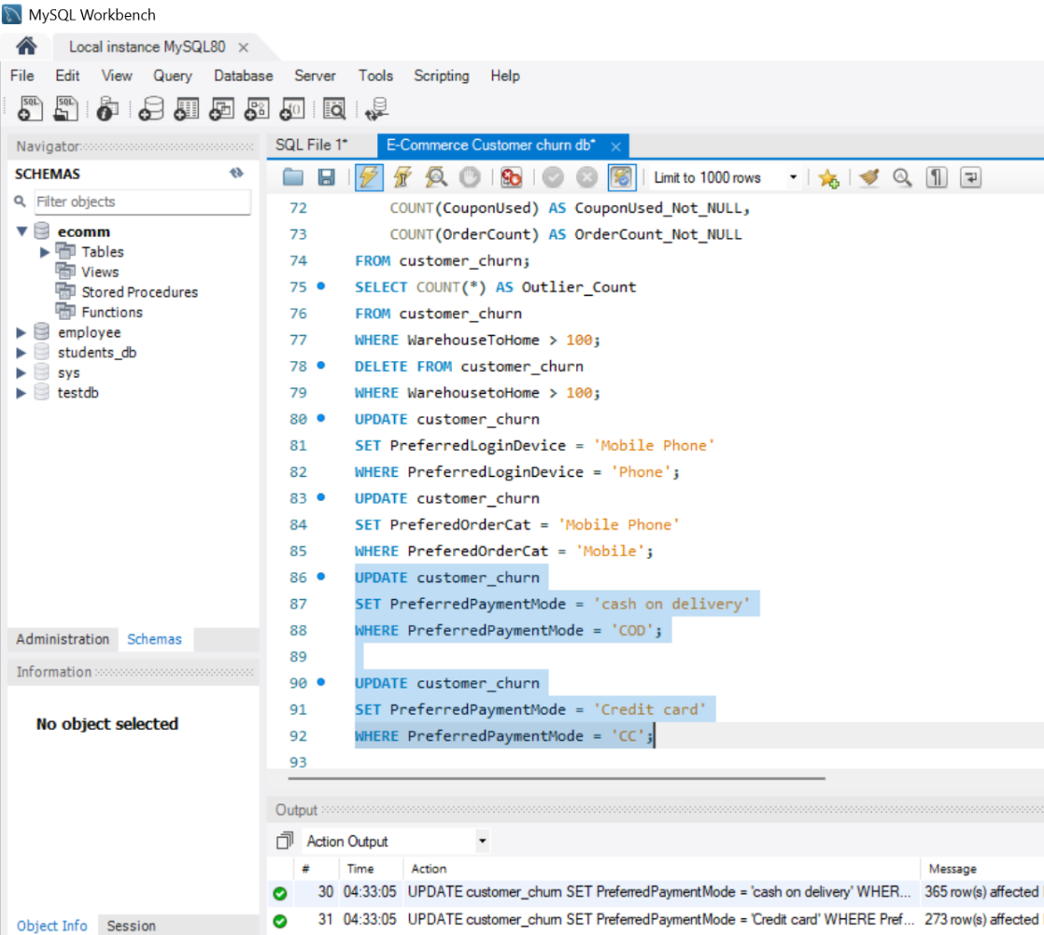

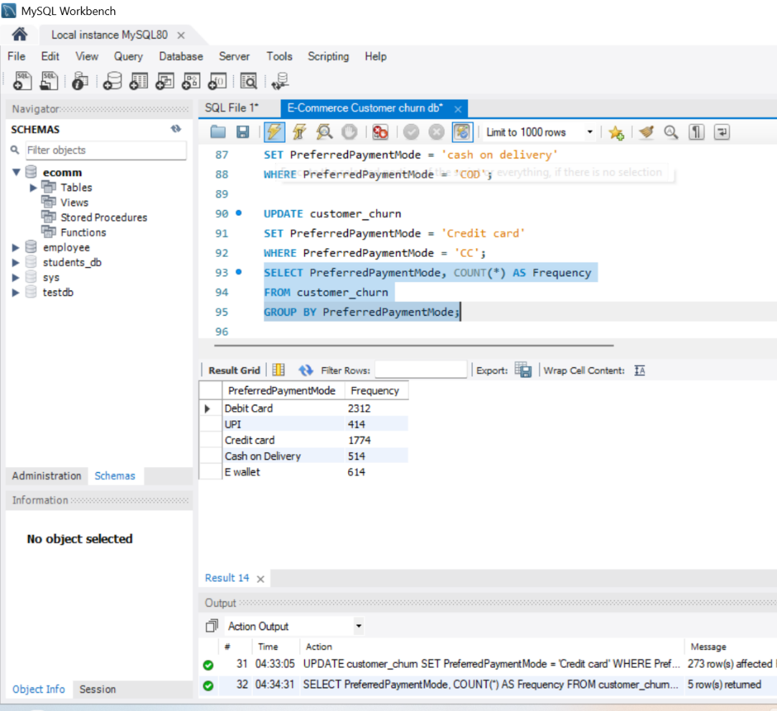

Data Transformation:
Column Renaming:
- Rename the column "PreferedOrderCat" to "PreferredOrderCat".
- Rename the column "HourSpendOnApp" to "HoursSpentOnApp".
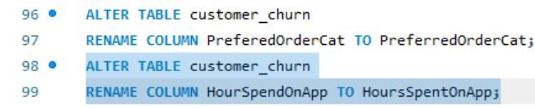

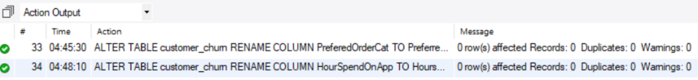

Creating New Columns:
- Create a new column named ‘ComplaintReceived’ with values "Yes" if the corresponding value in the ‘Complain’ is 1, and "No" otherwise.
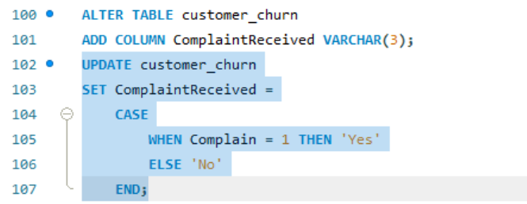

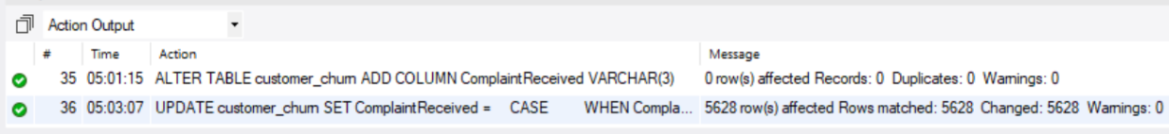

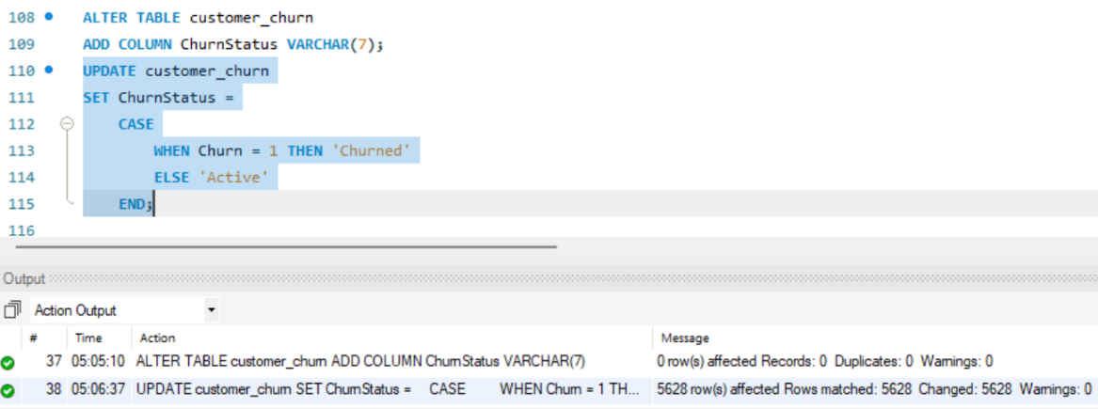
- Create a new column named 'ChurnStatus'. Set its value to “Churned” if the corresponding value in the 'Churn' column is 1, else assign “Active”.
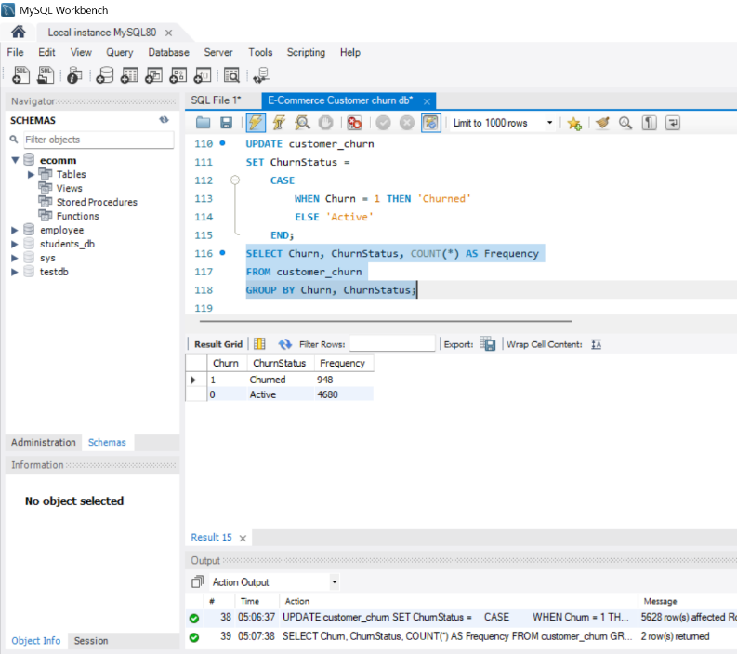

Column Dropping:
- Drop the columns "Churn" and "Complain" from the table.
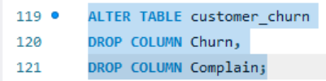

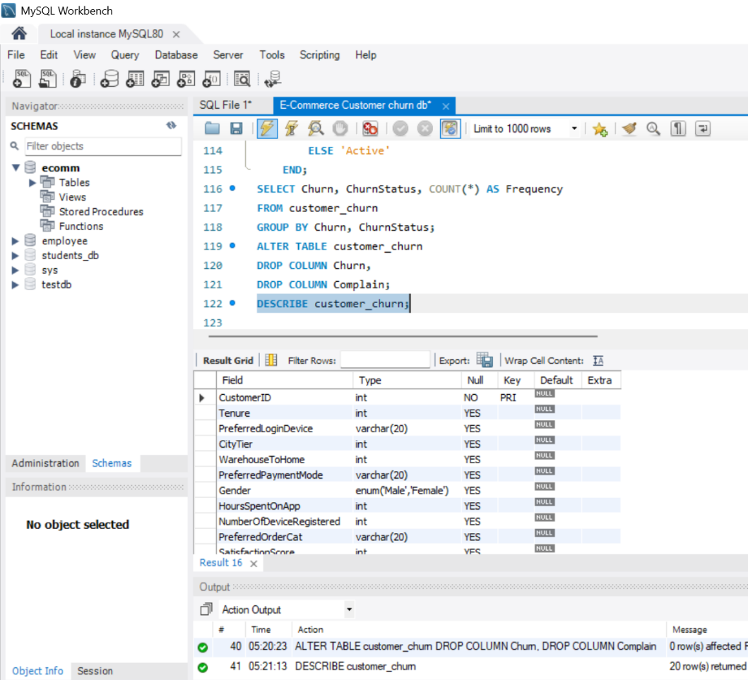

Data Exploration and Analysis:
- Retrieve the count of churned and active customers from the dataset.

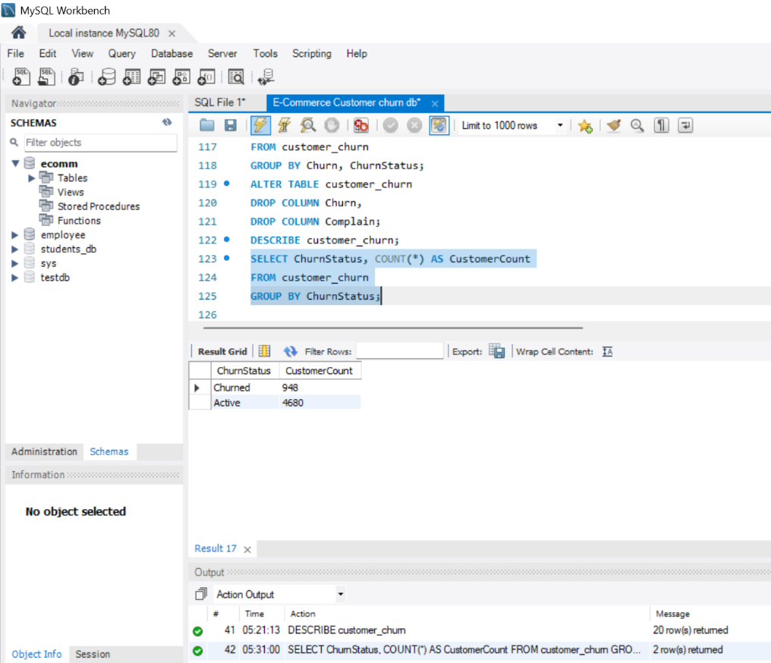

- Display the average tenure and total cashback amount of customers who churned.
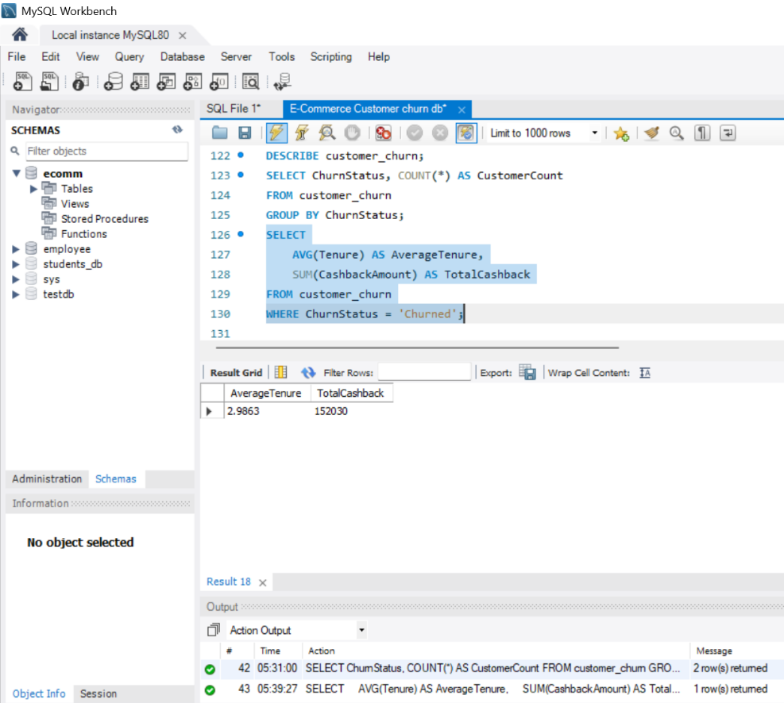

- Determine the percentage of churned customers who complained.
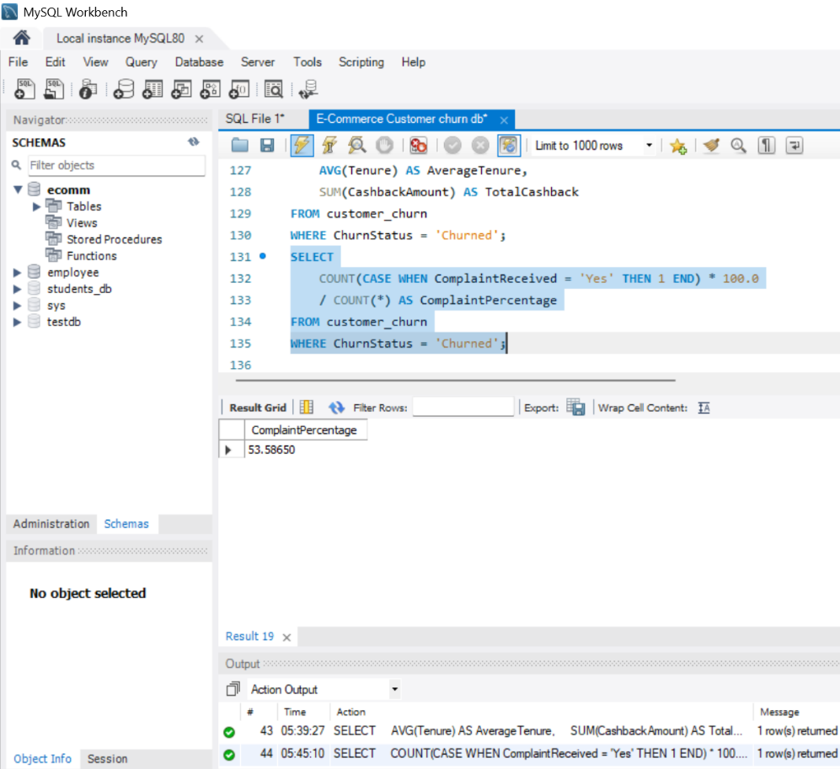

- Identify the city tier with the highest number of churned customers whose preferred order category is Laptop & Accessory.
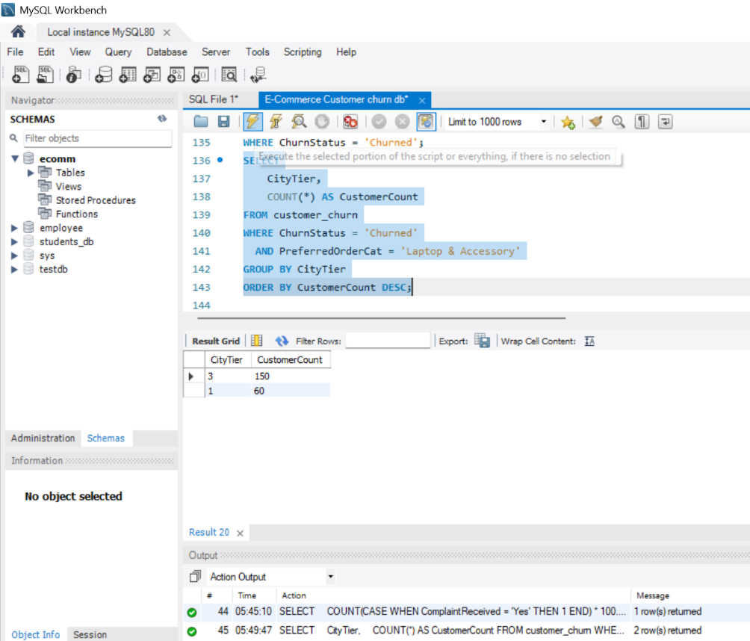

- Identify the most preferred payment mode among active customers.
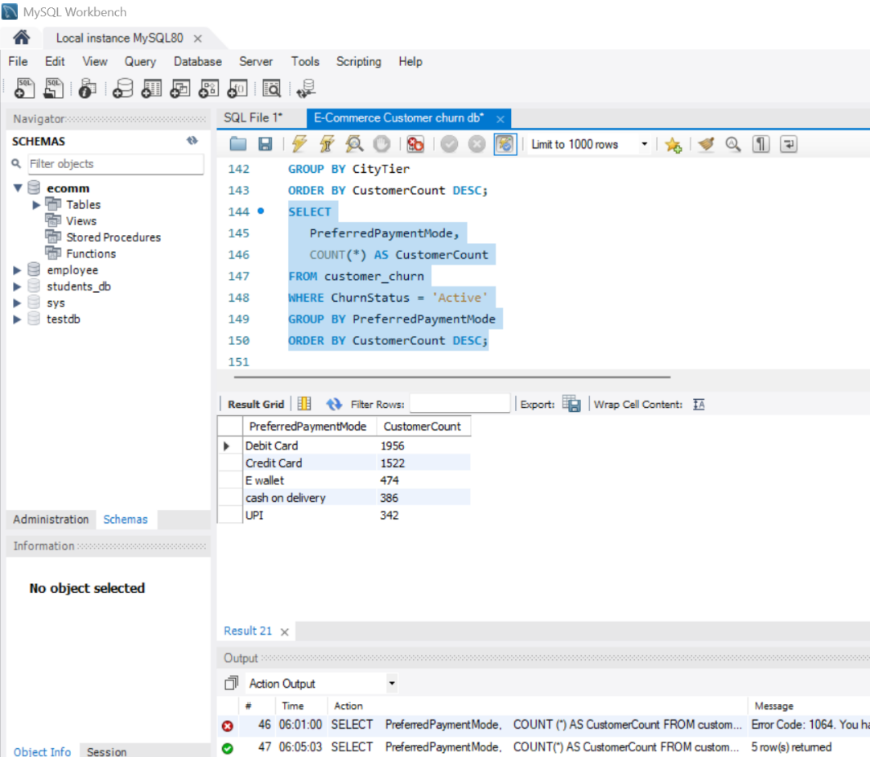

- Calculate the total order amount hike from last year for customers who are single and prefer mobile phones for ordering.
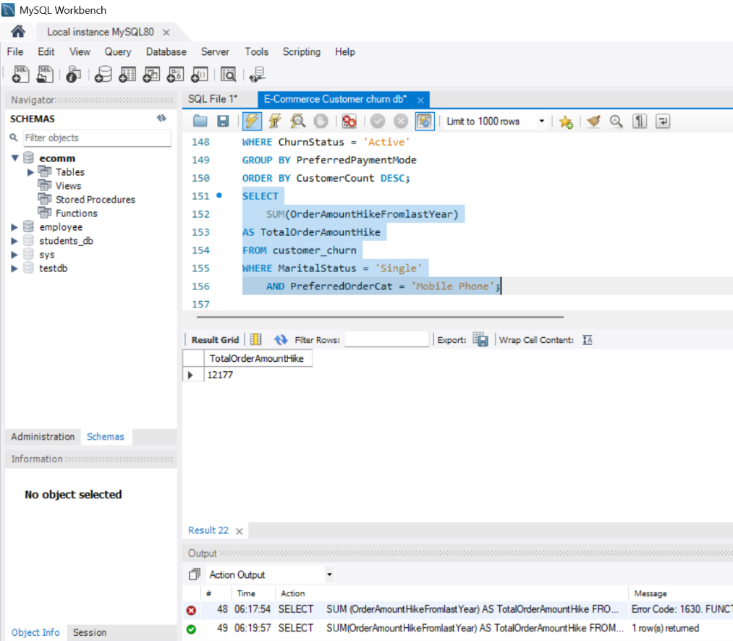

- Find the average number of devices registered among customers who used UPI as their preferred payment mode.
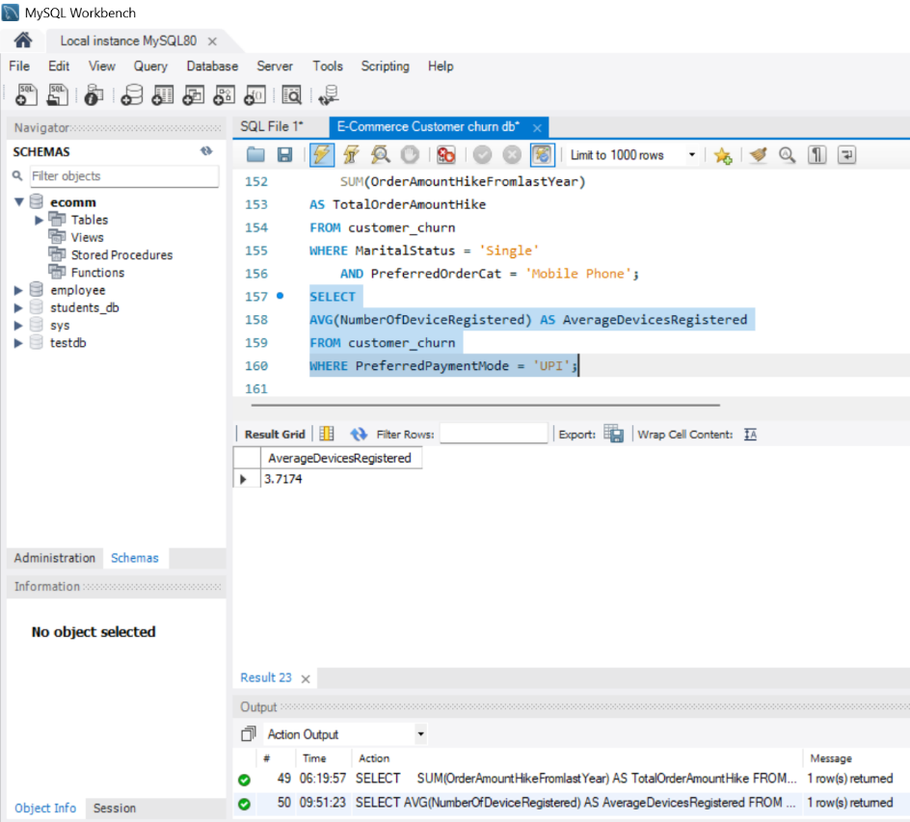

- Determine the city tier with the highest number of customers.
Ans: City Tier-1 has the highest number of customers with 3666 customers
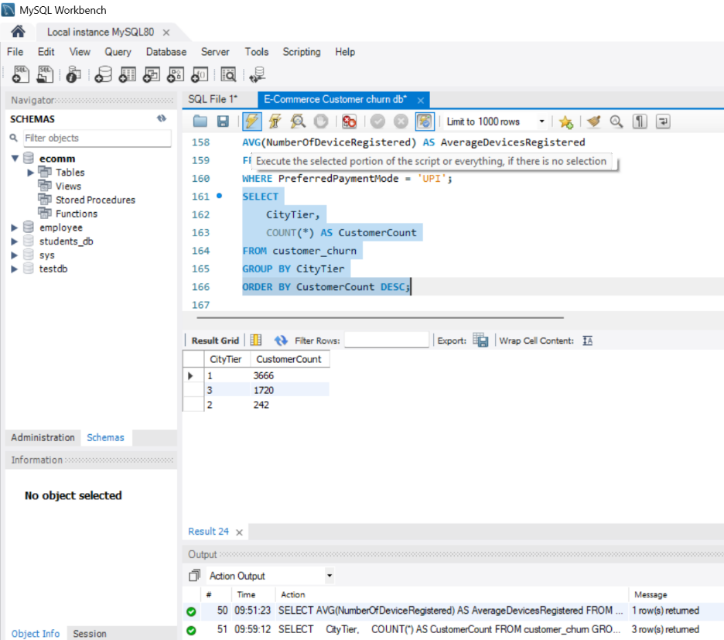

- Identify the gender that utilized the highest number of coupons.
Ans: Male customers utilized the highest number of coupons,with a total of 5470 coupons
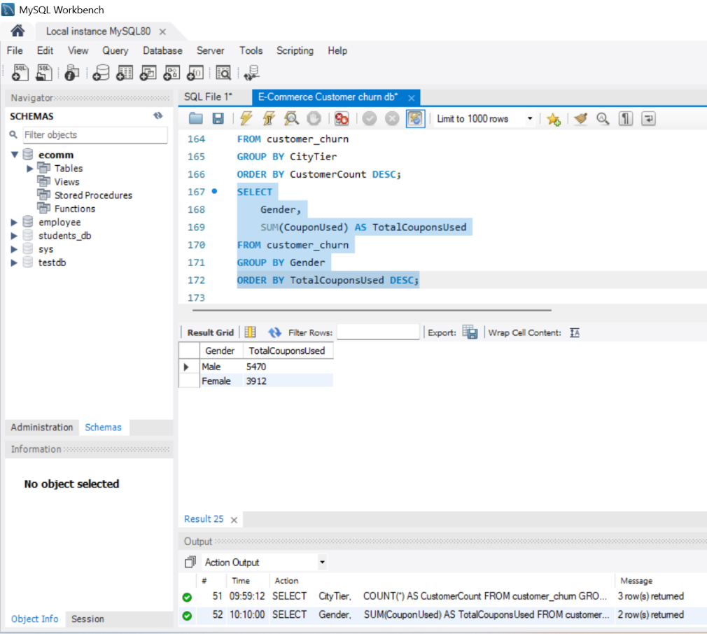

- List the number of customers and the maximum hours spent on the app in each preferred order category.
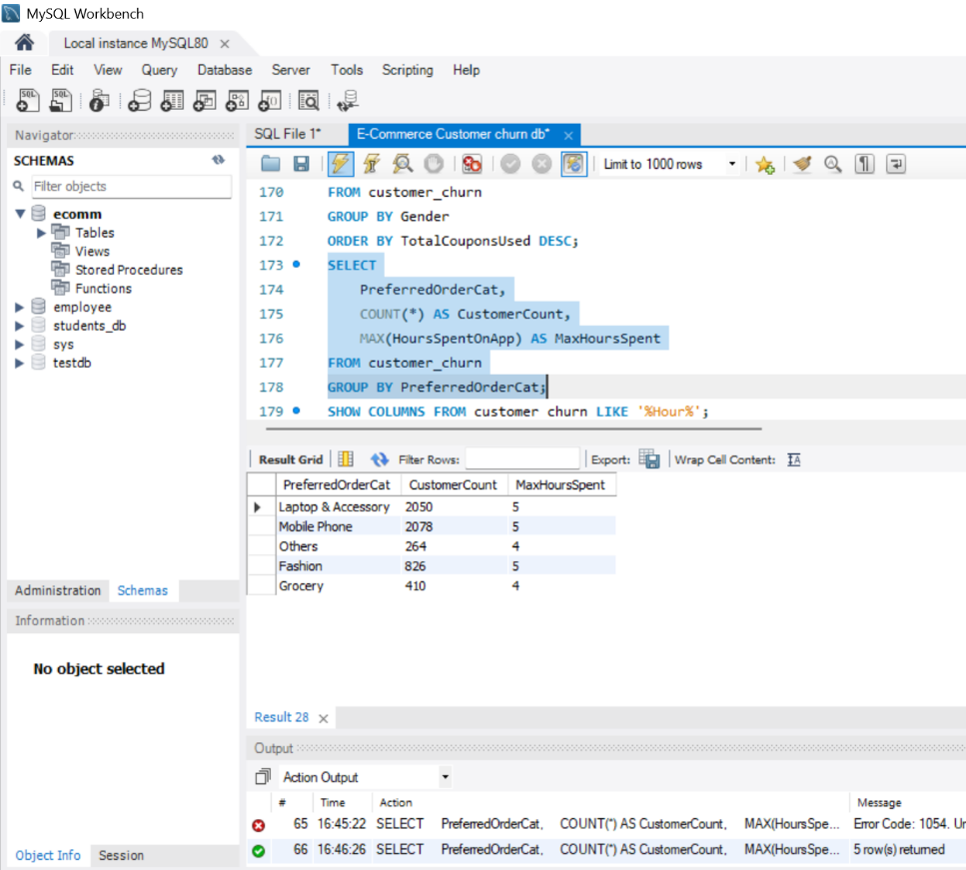

- Calculate the total order count for customers who prefer using credit cards and have the maximum satisfaction score.
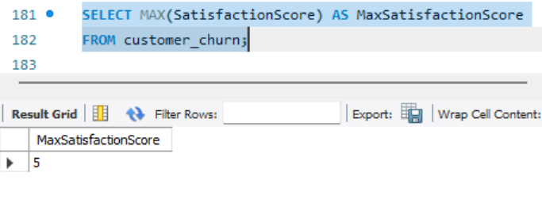

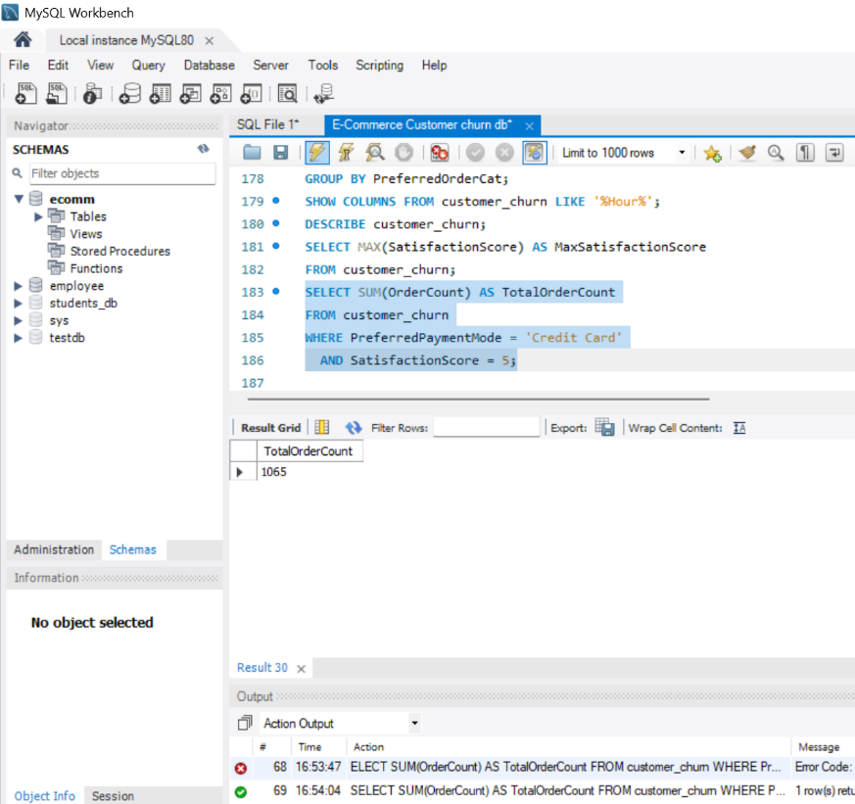

- What is the average satisfaction score of customers who have complained?
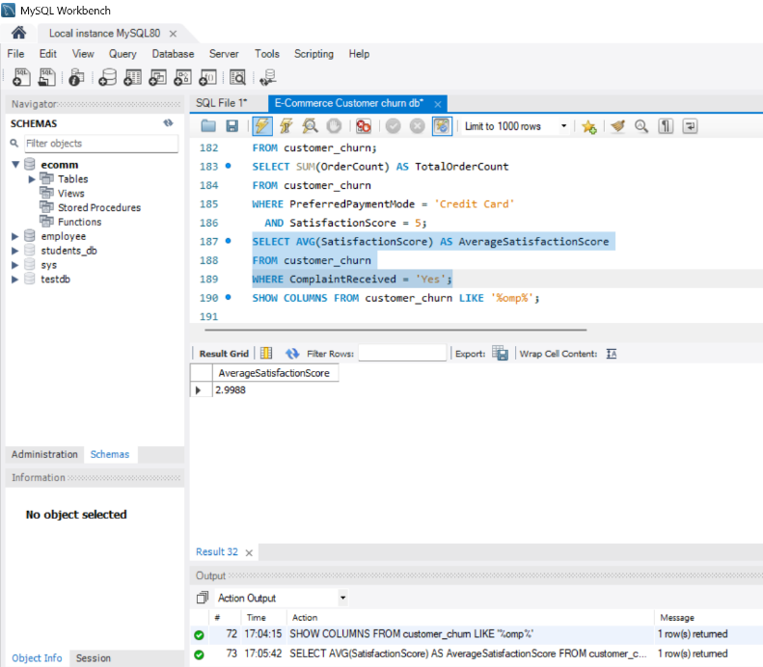

- List the preferred order category among customers who used more than 5 coupons.
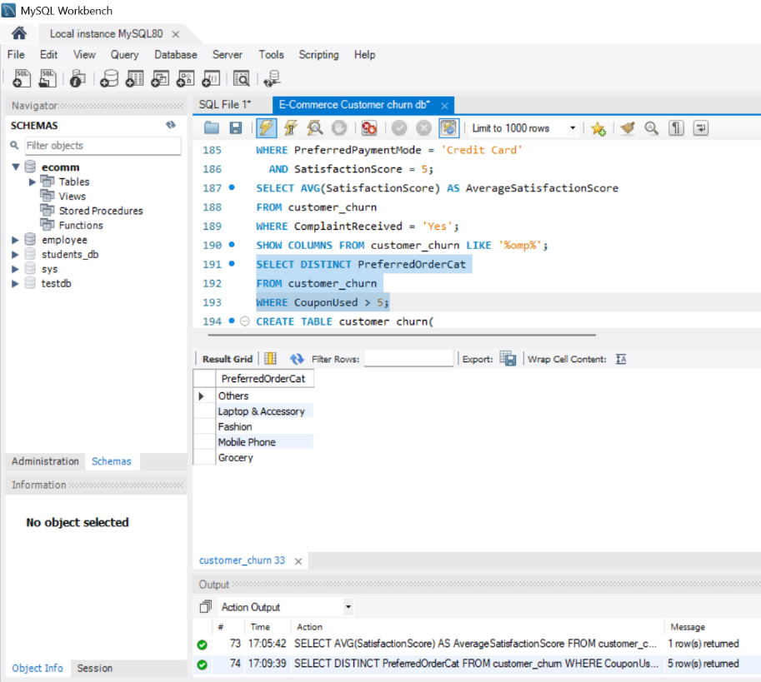

- List the top 3 preferred order categories with the highest average cashback amount.
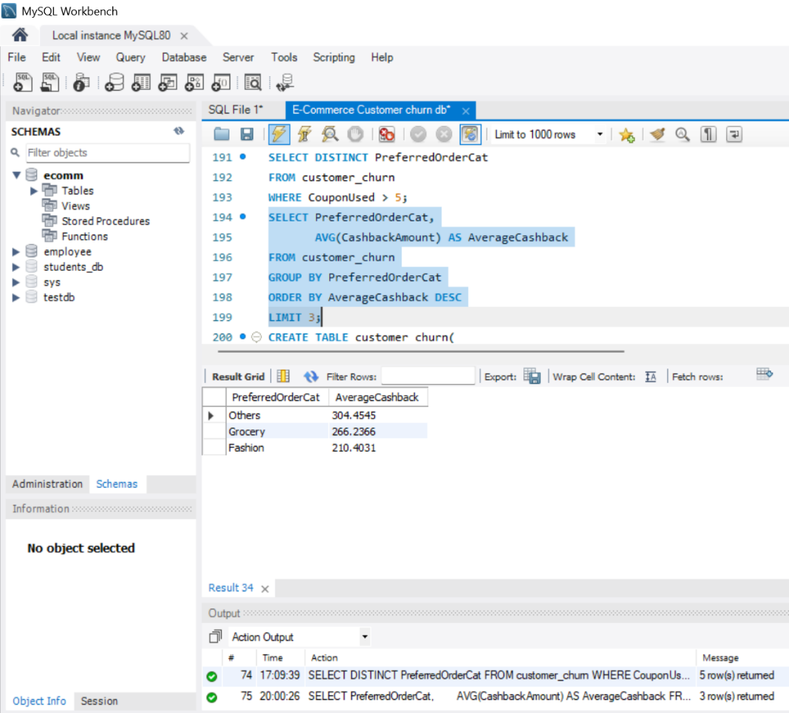

- Find the preferred payment modes of customers whose average tenure is 10 months and have placed more than 500 orders.
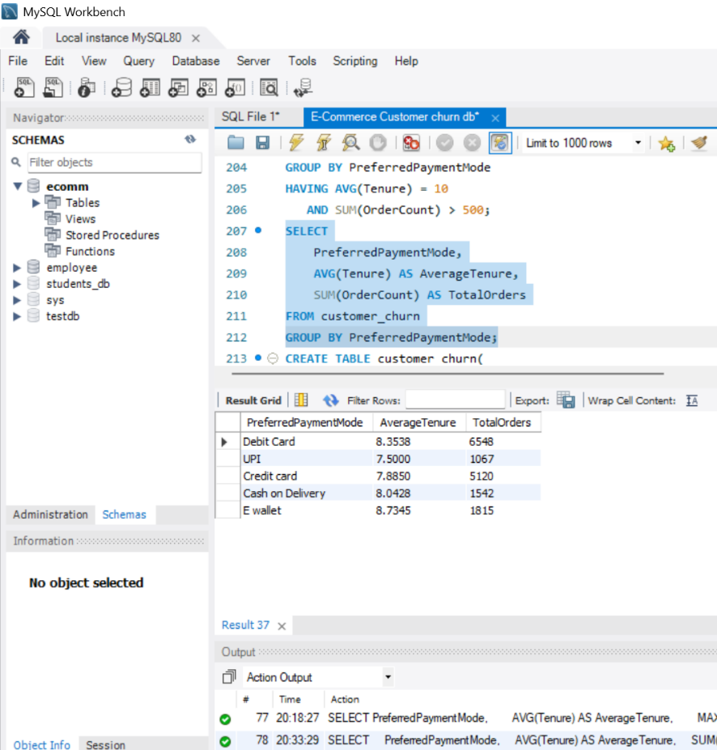

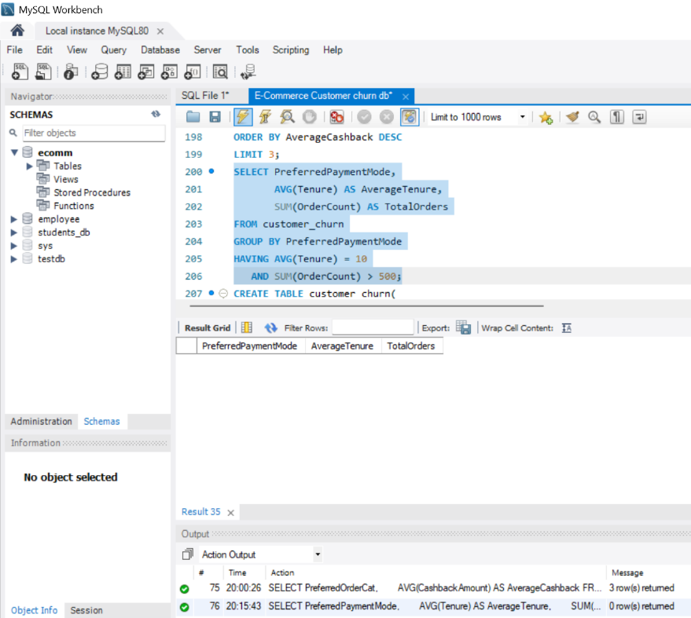

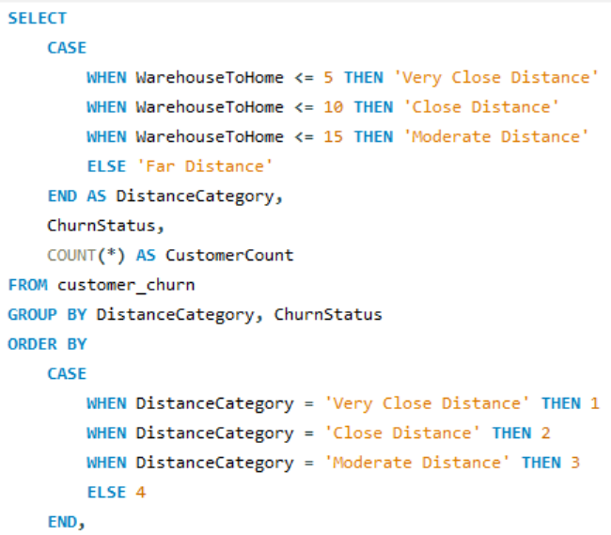
- Categorize customers based on their distance from the warehouse to home such as 'Very Close Distance' for distances <=5km, 'Close Distance' for <=10km, 'Moderate Distance' for <=15km, and 'Far Distance' for >15km. Then, display the churn status breakdown for each distance category.


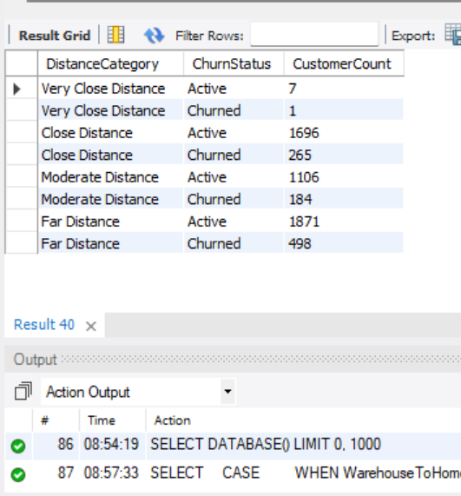

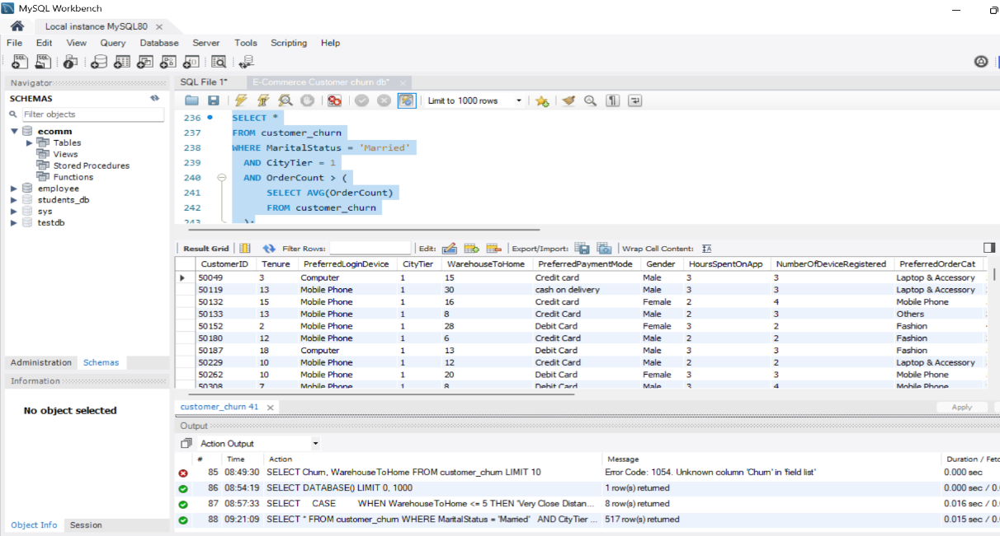
- List the customer’s order details who are married, live in City Tier-1, and their order counts are more than the average number of orders placed by all customers.

Return ID | Customer ID | Return Date | Refund Amount
1001 | 50022 | 2023-01-01 | 2130
1002 | 50316 | 2023-01-23 | 2000
1003 | 51099 | 2023-02-14 | 2290
1004 | 52321 | 2023-03-08 | 2510
1005 | 52928 | 2023-03-20 | 3000
1006 | 53749 | 2023-04-17 | 1740
1007 | 54206 | 2023-04-21 | 3250
1008 | 54838 | 2023-04-30 | 1990
- Create a ‘customer_returns’ table in the ‘ecomm’ database and insert the following data:
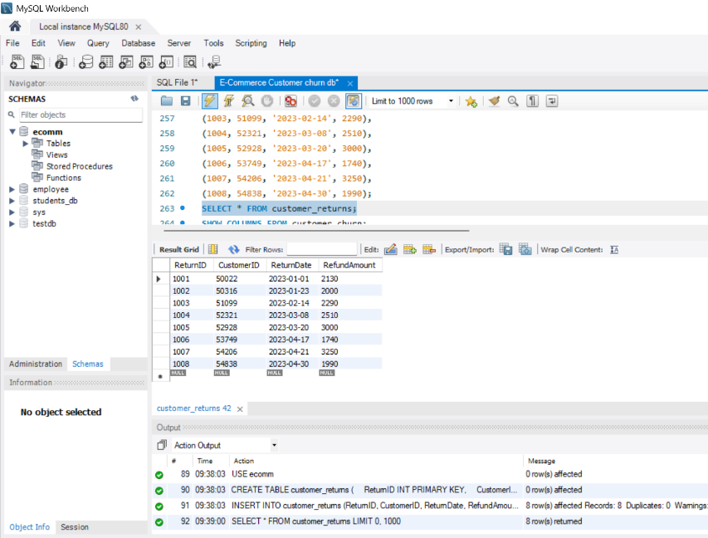

- Display the return details along with the customer details of those who have churned and have made complaints.
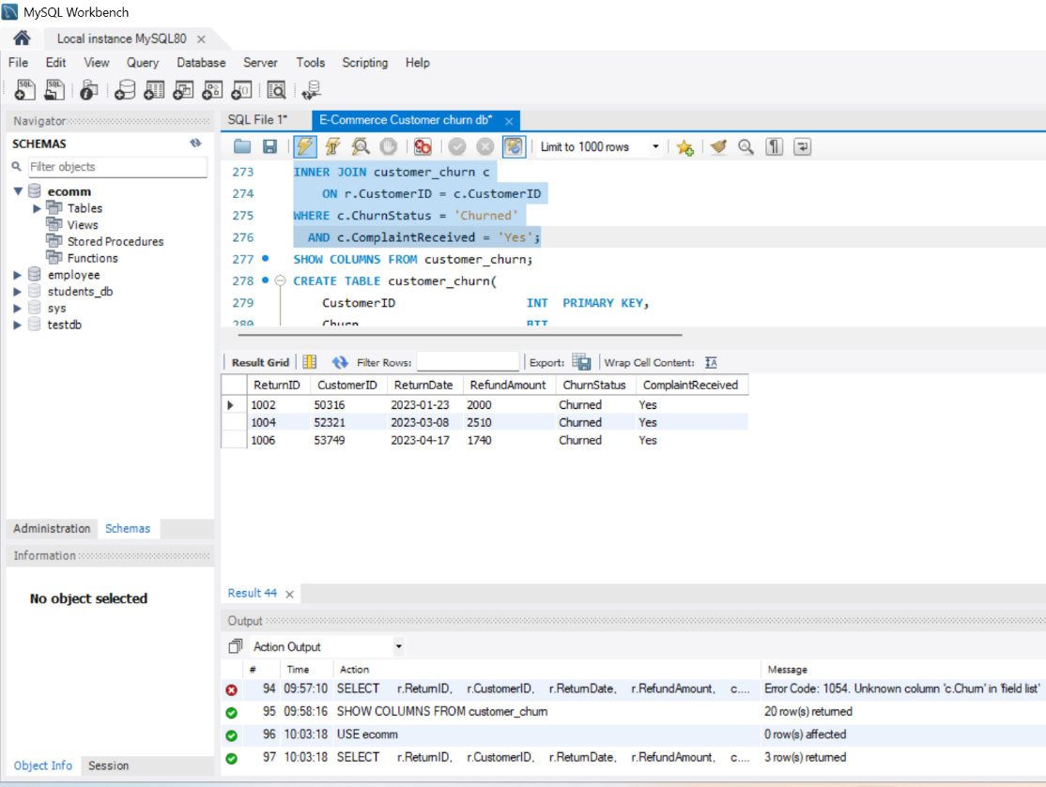

Conclusion
This assignment provided practical experience in using MySQL to analyze e-commerce customer churn data. Various SQL concepts such as filtering, aggregation, grouping, subqueries, CASE statements, JOINs, and table creation were used to extract meaningful customer insights. Overall, the assignment helped strengthen my understanding of SQL and its application in analyzing customer behaviour and business data.

